**Enterprise Standards and Best Practices for IT Infrastructure**

**Lab Report :** V-Motion

**IT13000554**

**Aaqil MFM**



**Sri Lanka Institute of Information Technology**

**B.Sc. Special (Honors) Degree in Information Technology**

**Specialized in Computer Systems & Networking**

**What is V-Motion?**

Vmotion allows the live migration of a running virtual machine’s (VM) from one physical server to another one with zero downtime, with continuous service availability, and complete transaction integrity, and it is transparent to users as well. Vmoation allows you to automatically optimize and allocate entire pools of resources for maximum hardware utilization and availability. Further it performs hardware maintenance without any scheduled downtime, and it proactively migrate VMs away from failing or underperforming servers.

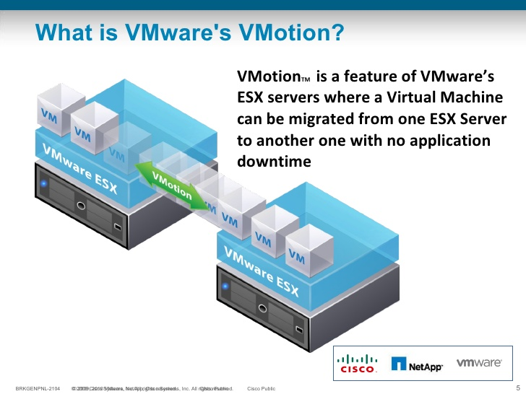

**How does Vmotion work?**

Initially, the entire state of a VM is encapsulated by a set of files stored on shared storage. VMware’s clustered Virtual Machine File System (VMFS) allows multiple installations of ESX Server to access the same virtual machine files concurrently.

After the initial step, the active memory and precise execution state of the VM is rapidly transferred over a high speed network. This process allows the VM to instantly switch from running on the source ESX Server to the destination ESX Server. VMotion keeps the transfer period invisible to users by keeping track of an on-going memory transactions in a bitmap. After the entire memory and system state has been copied over to the target ESX Server, then VMotion suspends the source virtual machine, copies the bitmap to the target ESX Server, and resumes the VM on the target ESX Server. This entire process just takes couple of seconds on a Gigabit Ethernet network.

Finally, the networks used by the VM are also virtualized by the underlying ESX Server. This ensures that even after the migration, the VM network identity and network connections are preserved. VMotion manages the virtual MAC address as part of the process. Once the destination machine is activated, VMotion pings the network router to ensure that it is aware of the new physical location of the virtual MAC address. Since the migration of a virtual machine with VMotion preserves the precise execution state, the network identity, and the active network connections, the result is zero downtime and no disruption to users.

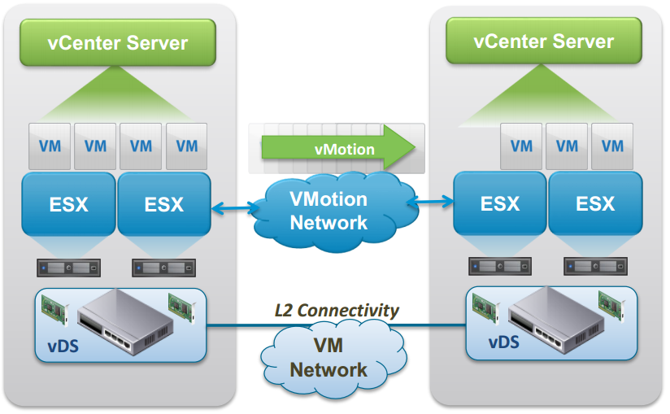

**What are the requirements to configure VMotion**

* CPU compatibility
* VMotion interference (minimum 1Gb adapter)
* Shared central mass storage
* Same naming for virtual port groups
* Sufficient resources on the target host
* At least one VSphere essentials plus license on the corresponding ESX host

**Advantages of VMotion**

* Automatically optimize and allocate the entire polls of resources
* Move VM’s from failing or underperforming priorities
* Minimizes schedule downtime
* Storage VMotion